____________________ County Conservation District

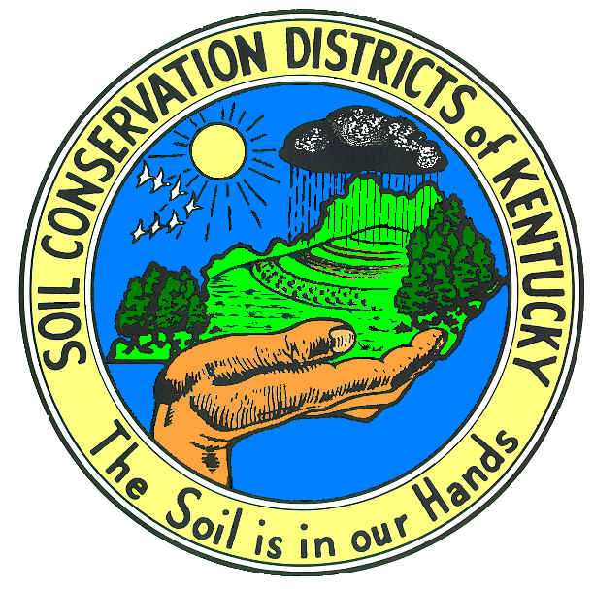

POLICY AND PROCEDURE MANUAL

Mission Statement

The mission of the ____________________ County Conservation District is to eliminate and/or control soil erosion and water pollution. To maintain and/or improve the quality of our environment by planning and wise use of sound conservation practices. By encouraging all land users to become cooperators and to develop water quality plans for their land.

Disclaimer
All programs and services of the ____________________ County Conservation District are offered on a non-discriminatory basis without regard to race, color, national origin, sex, religion, age disability, political beliefs and marital or family status.
Purpose of Conservation Districts According to
Kentucky Revised Statutes (KRS 262.020)
The purpose of a Conservation District is to conserve and develop all renewable natural resources within district. In so doing, the district is authorized to undertake, sponsor, participate in programs that promote the conservation, development, maintenance management, and wise use of the land, water, trees, and other related, natural resources in the district.

Kentucky’s Conservation Districts are subdivision of state-government and have been organized for the special purpose to assist landowners and land users:

- In solving soil and water resource problems.

  - Setting priorities for conservation work to be accomplished.

  - Coordinating the federal, state, and local resources needed to accomplish this work.

Management
Responsibilities of District Supervisors

- Develop written personnel policies
- Ensure that personnel management is conducted according to written policy.
- Be certain that personnel policies are adequate and current.
- Insure that all employees are well trained and conducted annual performance evaluations for all districts.

The ____________________ County Conservation District will look to the state (Division of Conservation) as the primary source in personnel matters and coordinate personnel management activities through them in order to comply with applicable state laws and regulations.

Supervisors will refer to the Conservation District Supervisors Pocket Guide (Third Edition) for information on job duties.

The Board may delegate to the Chairman, to one or more Supervisors, or to one or more employees such powers and duties as it may appear proper.

The Secretary/Treasurer of the Board of supervisors shall be bonded annually.

Conservation District Governing Body
Each local Conservation District is governed by a seven-member Board of supervisors elected by the registered voters with the district. These Supervisors serve terms of fours years. Supervisor elections are held every two years, with the three supervisors being elected one time and four the next time. District supervisors cannot hold any other elective office and serve without pay. Supervisors may be reimbursed for expenses incurred in the discharge of their duties and may be paid per diem for attending meetings or otherwise discharging the obligations of office.

The ____________________ County Conservation District Board of supervisors is comprised of a diverse group of individuals who are elected to a four-year term in office. New members are welcomed at the beginning of their term and each member takes their responsibilities seriously.

The Chairman presides over all Board Meetings and is actively involved in many committees throughout the year. He/she regularly attends scheduled leadership meetings. This helps him/her to stay informed of the many projects and requirements of his/her position as chairman.

Vice Chairman is also active in many committees throughout the year and is always ready to fill in when the Chairman is unable to attend a meeting.

Secretary-Treasurer keeps up to date on all the District’s activities by staying in close contact with the District’s administrative secretary. His/her duties include, but are not limited to overseeing the financial status and financial reports of the District’s General Funds account and all other accounts. He/she reviews all monthly, quarterly, and annual reports. He/she attends the KACD Convention and Area 9 Meetings regularly to stay informed. He/she also attends leadership training when meetings are scheduled for this area.

All other Board Members are also actively involved in the success of the ____________________ County Conservation District. They attend and actively participate in monthly board meetings, are involved in special committee meetings and also participate in the Annual Awards Banquet, Annual Soil Stewardship Dinner, Tree Give Away, and other important projects and events.

This Board has the expertise of a Field Representative and confer with their representative regularly on issues of importance to be sure the ____________________ County Conservation District is always up to date with recent issues and programs.

The Board works closely with office personnel, FSA, NRCS and the ____________________ County Cooperative Extension Service on all related conservation issues in ____________________ County. Board members stop by the office regularly to see if any questions or issues require their attention and do not limit their visits to monthly board meetings.

Departmental Polices
The ____________________ County Conservation District maintains written policies and procedures, which pertain to the overall operation of the service.

Supervisors and employees are expected to be aware and adhere to these policies and procedures.

Each employee and supervisor will read and sign a written form stating they have read and understand the handbook. Any questions about this handbook should be directed to the Chairman of the ____________________ County Conservation District.

All other Supervisors questions and concerns are addressed in the Conservation Districts Pocket Guide. A copy is on file in the ____________________ County Conservation District office and all supervisors have a copy provided by the field representative.

Equal Opportunity Employer
The ____________________ County Conservation District will, without regard to age, race, sex, religion, national origin, physical or mental handicap, hire individuals considered to be the best matched to perform the defined duties and responsibilities of the position to be filled.

Ethics
All employees and supervisors should conduct themselves in manners that will reflect credit upon themselves, their profession and the ____________________ County Conservation District. All laws and regulations of the Natural Resource Conservation Service will apply to all district employees.

Information
Information included in these personnel policies and procedures are not intended to represent a contract and may be changed by the ____________________ County Conservation District at any times.

Classification of Employees
A full time employee is one who is regularly scheduled 40 hours per week, whose employment is for a specific term, who has complete the initial probation period. The ____________________ County Conservation District currently employs a full time Administrative Secretary, and a full time District Technician to complete required district operations.

Compensation Plan
Pay periods: Employees will be paid semi-monthly; each employee keeps time sheets. The original is filed with the district records and a copy is mailed to the Division of Conservations Frankfort office each month. The Administrative Secretary will keep a record on file of holidays, vacation days and sick time earned and used.

Wages:
The ____________________ County Conservation District will take into consideration wage increases annually (June). Wage increase are not guaranteed, but are intended to reward, attract, retain and motivate staff. The ____________________ County Conservation District makes every effort to offer wages that are competitive and will attract and retain competent staff. The ____________________ County Conservation District will pay 4 % increase annually in January.

Payroll Deductions
Automatic payroll deductions will be made for all mandatory deductions, i.e. FICA, state and federal tax withholdings, and retirement.

Insurance
The ____________________ County Conservation District will provide health insurance to the District Administrative secretary.

Retirement
The ____________________ County Conservation District will pay their percentage of all full time employees retirement, in accordance with KRS 61.565 recommendations.

Workers Compensation
Employees of the ____________________ County Conservation District are covered by worker compensation insurance, as required by law.

Employment Compensation Benefits
Employees of the ____________________ County Conservation District are covered by employment insurance benefits as required by law.

Vacation
It is the policy of the ____________________ County Conservation District to grant paid vacation to all eligible full time employees. Vacation time is calculated on the basis of years of service as follows.

Employee accrues 8 hrs monthly @ 96 hrs yearly

Employees are urged to use all vacation hours earned each year. Vacation hours will be carried over into the next fiscal year at rate of 48 hours yearly. All vacations must be scheduled to ensure that the office is covered during regular working hours, each day.

Sick Leave
The employees of the ____________________ County Conservation District will accrue sick leave at an annual rate of 8 hrs. a month with 96 hours annually. Sick leave may be carried over from fiscal year to fiscal year. All employees are required to call in and report to the service center if taking sick leave at an unexpected circumstance.
Bereavement Leave
Employees may be paid for bereavement leave when an immediate family member has passed away.
Holidays
The employees will observe all federal and state holidays with pay.

Travel
Travel will be set at the state rate and will be updated regularly by the Field Representative.

Inclement Weather
Eligible full time employees will receive their regular eight hours pay; on days the office is closed by NRCS due to inclement weather. All other days that the office is not closed will not be considered an inclement weather day. Employee will not be paid for these days unless they use their own personnel days.

Resignation
Any employees who intends to resign is required to give at least two (2) weeks notice in writing to the Chairman of the Conservation District in order to receive accumulated benefits. The final employee check will reflect these benefits.

Discipline and Discharge
The ____________________ County Conservation District shall have the right to discharge employees during their probationary period without cause or without recourse to grievance procedure. The ____________________ County Conservation District shall have the right to discipline or discharge employees for “just cause.” The following will be considered cause for immediate discharge without warning:
  - Dishonesty
  - Insubordination
  - Failure to fulfill responsibilities of job description
  - Gambling while on duty
  - Revealing confidential information concerning customers,
  - Drinking alcoholic beverages or being under the influence of alcoholic beverages while on work premises.
  - Using or being under the influence of narcotics i.e. marijuana or hallucinatory drugs
  - Carrying a concealed firearm without a permit
  - Proven falsification of records or reports
  - Sexual misconduct or reported sexual abuse to any other employee or customer
  - Willful damage to office property.
  - Use of internet for viewing of offensive material.

All other violations will be confronted with three warnings before termination investigations are looked into. All employees must be responsible and willing to work with all agencies. (DOC, NRCS, FSA, and UKCES) They must report to the 7-member board of supervisors. The ____________________ County Conservation District board of supervisors will form the governing body that maintains supervision of all employees to comply with all rules and regulations.

Discharge
Quitting without proper notice required may be regarded as cause for denying the reemployment status of the employee

Scholarships
The ____________________ County Conservation District offers $1000.00 scholarships annually to high school students majoring in a field of natural resources, conservation or agriculture. The student/s must be a resident of ____________________ County. The students will be chosen based on their academic information and community involvement. Students will not be judged based on race, sex, ethic background, age, disability, political beliefs, financial status and marital or family status.

Funding
The above policies and procedures are subject to change due to funding issues.

I have read and understand this handbook and agree to follow these procedures and policies, which pertain to the overall operation of this service

Chairman Date Vice Chairman Date

Secretary /Treasurer Date Member Date

Member Date Member Date

Member Date

I have read and understand this manual and agree to follow these policies and procedures, which pertain, which pertain to the overall operation of this service. Reading this policy and procedure handbook and being employed by the ____________________ County Conservation District does not serve as a contract between the Conservation Board of Supervisors and me.

Administrative Secretary Date

District Technician Date

Effective Date:__________________________

